**AV Scenario Simulation**

**Assumptions:**

Total area of plot = 1 Acre = 43560 sq. ft.

Shape = Square (Length and width of plot are equal) = 208.71 ft. * 208.71 ft.

No buffer at the edge of plot because we want to estimate net return from 1 acre so our estimation will do benefit cost analysis of return per acres in the State of Alabama.

Solar panel size = 7.75 ft by 3.5 ft.

Non-transparent solar panels which blocks sunlight and generates shadow on the ground.

Solar panel height: The capital expenditure cost (CAPEX) varies with the height of solar panels (Source: <https://www.nrel.gov/docs/fy21osti/77811.pdf> Table 1 and Fig 3).

4.6 ft

* Capex = $1.75/W (Tracking System)
* Capex = $ 1.60/W (Non-tracker System)

6.4 ft

* Capex = $1.93/W (Tracking System)
* Capex = $1.85/W (non-tracking System)

8.2 ft (not necessary for simulation)

* Capex = 2.11/W (Tracking System)
* Capex = $2.33/W (non-tracking System)

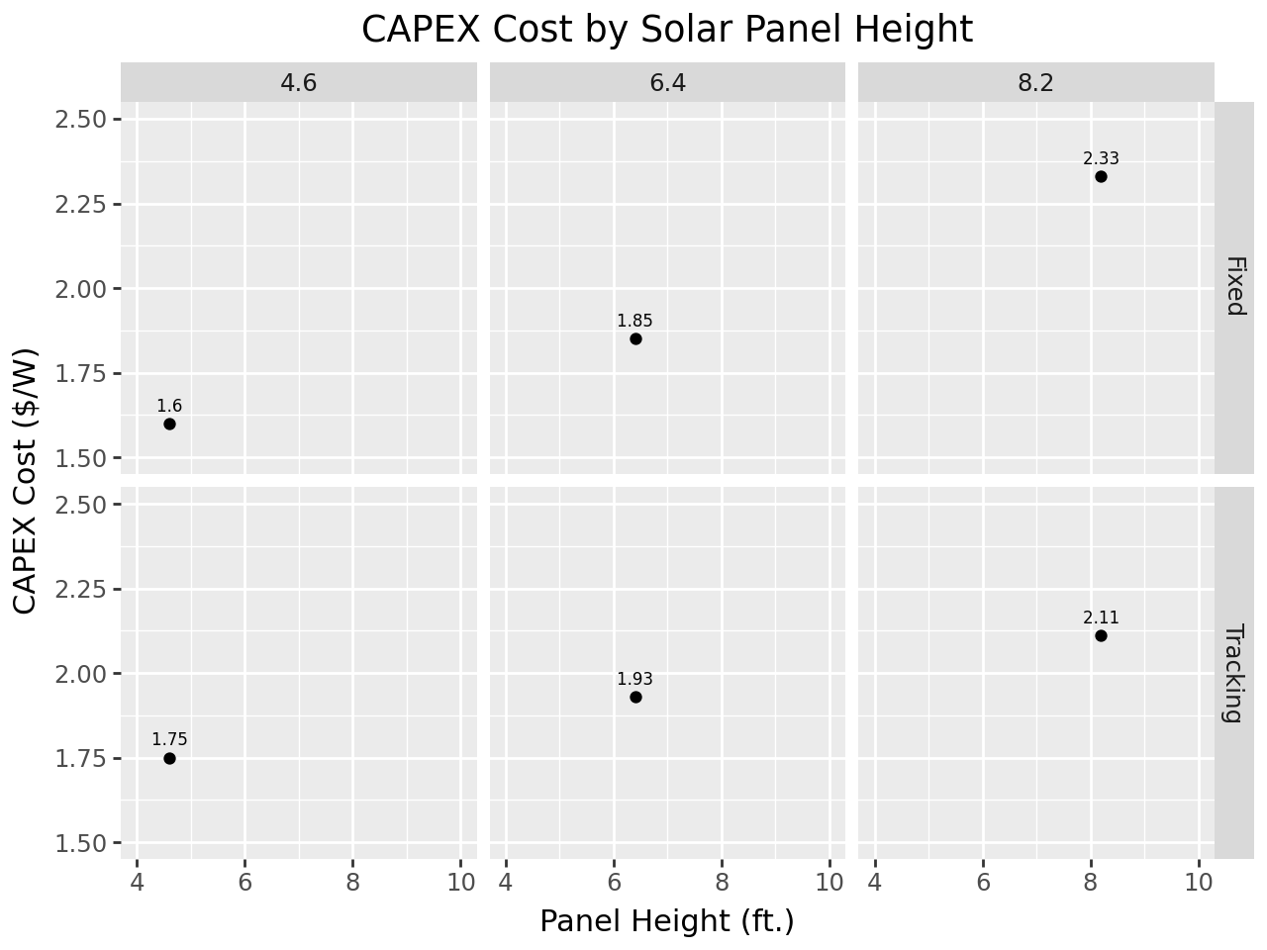

Four regions of Alabama (north, central, black belt, south) (Electricity price, solar potential, electricity generated)

We assumed two types of tracking solar panels: 1) single axis sun-tracking solar panel (rotates up to 60o angle on both sides of horizontal beam) and 2) single axis non-tracking solar panels (solar panel surface always remain parallel to the ground surface) both mounted on horizontal beam supported by two poles on the either side of the row.

We assumed agricultural activities use manual labor and small equipment such that buffer spacing to move agricultural equipment is not necessary. The spacing between solar panels allocated for agricultural crops is enough to move and use small agricultural equipment. There is no walking or passing space within the one-acre plot.

Solar energy is not produced in crop only scenario and crop is not grown in solar only scenario. Agricultural crops are planted parallel to solar panels in open spaces and under the solar panels in agrivoltaics scenarios. The crop density is affected by row-to-row spacing and plant-to-plant spacing of given crop and not by solar panel orientation, rotation, or spacing. The yield of crops are assumed to vary based on solar radiation that plants received which was not blocked by solar panels. Solar panels creates shadow which could have positive and negative effects on crop yield. So, we simulated crop yield variation from -50% to 200% assuming the range of yield variation due to the fluctuation in solar radiation received by the plant.

**Limitation of our study:** The land requirement may be higher than 1 acre to comply with the local, state, and federal government policies. The land requirement and profitability of operation may vary based on the scale of operation. So, our analysis should be taken as reference benefit cost analysis estimation from one acre of land for given agrivoltaic system operation. Also, this estimation can be taken as a reference estimation for a larger agrivoltaic farm which has multiple one-acre plots solely allocated for agrivoltaics operation and additional land available to meet regulatory obligations and moving spaces between plots. It should not be taken as a benefit cost analysis from one acre plot from which land is allocated to fulfill regulatory obligations and other logistic arrangements needed to build AV onsite farm because several regulatory obligations in local, state, and federal level and the local context for agrivoltaic system development at the given location were not completely and accurately accounted in this research. Also, logistic requirements such as walking space, space for machinery storage and additional land buffers needed are not incorporated in this simulation.

**Spacing for Strawberry:**

Plant-to-plant spacing is 2 ft.

Row-to-row spacing is 3 ft.

Strawberries grow from 0.5 ft to 1 ft. tall.

**Spacing for Tomato:**

Plant-to-plant spacing is 3 ft.

Row-to-row spacing 3 ft.

Tomato grow 3 (Determinate) to 6 ft tall (Indeterminate).

Solar Energy System Parameters:

DC system Size (kW) = Array area (m2) * 1Kw/m2 * Module Efficiency (%)

Module Type: Standard (Crsytalline silicon, 19% approximate nominal efficiency, model covered with glass with anti-reflective coating, and -0.37%/oC temperature coefficient.

Array type: Fixed (open rack) and One axis tracking.

Tilt degree: 20o for Fixed (open rack) and 0o for One axis tracking.

Azimuth (deg) = 180.

System loss = 44.08

|  |  |  |
| --- | --- | --- |
| **Parameter** | **Descriptions** | **Parameter Levels** |
| Area | Total Area for Modeling | 1 Acre |
| Regions of Alabama | North  Central  Black Belt  Southern | North  Electricity Price  Electricity Generated  Central  Electricity Price  Electricity Generated  Black Belt  Electricity Price  Electricity Generated  Southern  Electricity Price  Electricity Generated |
| Height | Height of solar panels | 4 ft  CAPEX:  6 ft  CAPEX: |
| Electricity price | Electricity price in four regions of Alabama | North  Central  Black Belt  South |
| Solar Potential | Solar Potential of four regions of Alabama | North  Central  Black Belt  South |
|  |  |  |
| Total Solar Scenarios = 2 heights *4 Price *4 Regions Solar Potential = 32 | | |

One acre inside Auburn University Football Stadium (1 Acre = 43,560 sq. ft.) and ~835 ft. perimeter for a square. The square inside stadium is quite close to the plot designed.

The layout below needs to be updated.

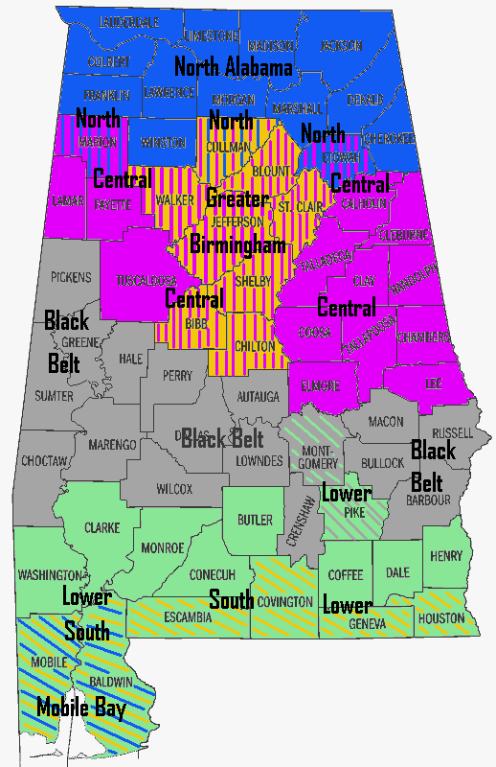

********************* IGNORE TEXT BEYOND THIS LINE ************************

**Paul’s Scenario:**

|  |  |  |
| --- | --- | --- |
| **Parameter** | **Descriptions** | **Parameter Levels** |
| Area | Total Area for Modeling | 1 Acre |
| Regions of Alabama | North  Central  Black Belt  Southern | North  Electricity Price  Electricity Generated  Central  Electricity Price  Electricity Generated  Black Belt  Electricity Price  Electricity Generated  Southern  Electricity Price  Electricity Generated |
| Height | Height of solar panels | 4 ft  CAPEX:  6 ft  CAPEX: |
| Electricity price | Electricity price in four regions of Alabama | North  Central  Black Belt  South |
| Solar Potential | Solar Potential of four regions of Alabama | North  Central  Black Belt  South |
|  |  |  |
| Total Solar Scenarios = 2 heights *4 Price *4 Regions Solar Potential = 32 | | |

Cost of AV (https://www.nrel.gov/docs/fy21osti/77811.pdf):

Total Profit (π) = Total Cost (C) – Total Revenue (R)

Total Cost (C) = Cost of Solar (Cs) + Cost of Tomato Production (Ct)

Source: The cost of PV + Crops (reinforced regular mount) holds panels at 8.2 ft above the ground while maintaining structural integrity under wind and snow loads.

Inter-row spacing is 44 degrees except for vertical mount (90-degree). Panel height taken from Table 1, Page 7, https://www.nrel.gov/docs/fy21osti/77811.pdf

Site preparation cost is included under install labor and equipment and contribute to difference in cost across the scenario.

Suggested Citation

Horowitz, Kelsey, Vignesh Ramasamy, Jordan Macknick and Robert Margolis. 2020. Capital Costs for Dual-Use Photovoltaic Installations: 2020 Benchmark for Ground Mounted PV Systems with Pollinator-Friendly Vegetation, Grazing, and Crops. Golden, CO: National Renewable Energy Laboratory. NREL/TP-6A20-77811. <https://www.nrel.gov/docs/fy21osti/77811.pdf>.